[1]

SMPS (Switched Mode Power Supply) (September, 2021)

First A. Abel M, Final year *Student, AAIT*, Second B. Euel F, Final year Student, AAiT

*Abstract* – This project is to design and simulate SMPS (Switched Mode Power Supply) with a proper protection system for the purpose of multiple load application. The SMPS have a multiple voltage output of 5V, 12V and 24V. The 5V output will be used for remote control car battery charger and needs 2A of current, the 12V output will be used for CCTV and uses 5A of current, the 24V spotlight used to light up spotlight and uses 3.75A of current. This project details the design process, construction, and testing of an AC-to-DC switch mode power supply. The SMPS is made with a 3-phase full bridge rectifier with a flyback converter. To increase the power efficiency and reduce losses we used zero current switching (ZCS) and zero voltage switching (ZVS) circuit. There is a circuit that will be used to protect the circuit from overvoltage and overcurrent.

*Index Terms*—SMPS, ZCS, ZVS

# INTRODUCTION

Switched-mode power supplies (SMPS), sometimes referred to as switch mode power supplies, have become the workhorse of efficient power conversion, taking a mains voltage AC input and converting it down to a low voltage DC output. AC-DC switched-mode converters are everywhere; the external desktop power supply for your laptop, inside your set-top box, and the wall plug-in charger for your smartphone.

In the past, a linear method of power conversion performed the conversion task. Linear power supplies typically require heavy and bulky transformers with analog “linear’ regulation circuitry. Due to average conversion efficiencies of less than 65%, transformers generate relatively large amounts of waste heat, which requires dissipation. By comparison, switched-mode power supplies are compact, power-efficient, typically better than 85%, and lightweight. Switched-mode power supplies are also extremely flexible from a design perspective, enabling designers to find an optimal solution for whatever power requirements their end-product might have. [1]

A switch mode power supply is a power converter that utilizes switching devices such as MOSFETs that continuously turn on and off at high frequency; and energy storage devices such as the capacitors and inductors to supply power during the non-conduction state of the switching device. The supplies have higher efficiencies of up to 90%, are small in size and widely used in computers and other sensitive electronic equipment.[2]

The basic switch mode power supplies (SMPS) are categorized based on supply input and output voltage. The main four groups are: [2]

1. AC to DC – Off-line DC power supply *
2. DC to DC – Converter
3. DC to AC – Inverter
4. AC to AC – Cycloconverter of frequency changer

The power switching stage performs the power conversion from the circuits input voltage, VIN to its output voltage, VOUT which includes output filtering. The major advantage of the switch mode power supply is its higher efficiency, compared to standard linear regulators, and this is achieved by internally switching a transistor (or power MOSFET) between its “ON” state (saturated) and its “OFF” state (cut-off), both of which produces lower power dissipation.

This means that when the switching transistor is fully “ON” and conducting current, the voltage drops across it is at its minimal value, and when the transistor is fully “OFF” there is no current flow through it. So, the transistor is acting like an ideal ON/OFF switch.

Unlike linear regulators which only offer step-down voltage regulation, a switch mode power supply can provide step-down, step-up and negation of the input voltage using one or more of the three basic switch mode circuit topologies: Buck, Boost and Buck-Boost. These names refer to how the transistor switch, inductor, and smoothing capacitor are connected together within the basic SMPS circuit.[3]

In this project, a three-output level AC-DC Switched Mode Power Supply (SMPS) is designed using a flyback converter with the protection circuit for overvoltage

and overcurrent. This SMPS will supply 5 V, 12 V and 24 V outputs. Most of commercially available Switched Mode Power Supplies (SMPS) use DC-DC converters. So, an isolated type of SMPS is chosen. The protection circuit will be used to maintain reliability of the loads.[4]

## Problem Statement

In designing a circuit, we must consider designing an efficient, stable power supply with a protection system for the reliability of the power delivered to the load. Otherwise, it will reduce the efficiency and stability of the power delivered to the load.

## Objectives

## Using SMPS with understanding of its operation

* Applying protection to the SMPS

# literature review

## Power Supply

A power supply is an electrical device that supplies electric power to an electrical load. The primary function of a power supply is to convert electric current from a source to the correct voltage, current, and frequency to power the load. As a result, power supplies are sometimes referred to as electric power converters. Some power supplies are separate standalone pieces of equipment, while others are built into the load appliances that they power. Examples of the latter include power supplies found in desktop computers and consumer electronics devices. Other functions that power supplies may perform include limiting the current drawn by the load to safe levels, shutting off the current in the event of an electrical fault, power conditioning to prevent electronic noise or voltage surges on the input from reaching the load, power-factor correction, and storing energy so it can continue to power the load in the event of a temporary interruption in the source power (uninterruptible power supply). [5]

1. ***Types of Power Supply***

There are different types of Power supplies, those are AC power supplies, DC power supplies, Programmable power supply, Uninterruptible power supply, High-voltage power supply and Bipolar power supply.

* 1. ***AC power supplies***

An AC power supply typically takes the voltage from a wall outlet (mains supply) and uses a transformer to step up or step down the voltage to the desired voltage. Some filtering may take place as well. In some cases, the source voltage is the same as the output voltage; this is called an isolation transformer. Other AC power supply transformers do not provide mains isolation; these are called autotransformers; a variable output autotransformer is known as a variac. Other kinds of AC power supplies are designed to provide a nearly constant current, and output voltage may vary depending on impedance of the load. In cases when the power source is direct current, (like an automobile storage battery), an inverter and step-up transformer may be used to convert it to AC power. Portable AC power may be provided by an alternator powered by a diesel or gasoline engine (for example, at a construction site, in an automobile or boat, or backup power generation for emergency services) whose current is passed to a regulator circuit to provide a constant voltage at the output. Some kinds of AC power conversion do not use a transformer. If the output voltage and input voltage are the same, and primary purpose of the device is to filter AC power, it may be called a line conditioner. If the device is designed to provide backup power, it may be called an uninterruptable power supply. A circuit may be designed with a voltage multiplier topology to directly step-up AC power; formerly, such an application was a vacuum tube AC/DC receiver. [5]

Such example is AC adapter, An AC adapter is a power supply built into an AC mains power plug. AC adapters are also known by various other names such as "plug pack" or "plug-in adapter", or by slang terms such as "wall wart". AC adapters typically have a single AC or DC output that is conveyed over a hardwired cable to a connector, but some adapters have multiple outputs that may be conveyed over one or more cables. "Universal" AC adapters have interchangeable input connectors to accommodate different AC mains voltages.

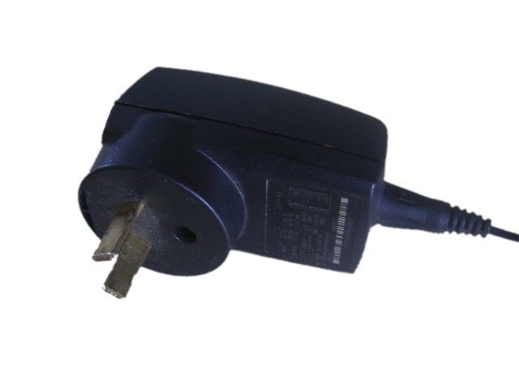

Fig 1 – Switched mode power adapter

* 1. ***Programmable power supply***

Programmable power supplies are power supplies that deliver remote control capabilities to the output voltage(s) via an analog control signal that can be regulated using a keypad or rotary switch often found on the front panel. RS232, GPIB, USB, or other computer interfaces can be used as well. Common programmable functions for the power supply include voltage output and current. In the case of AC power supplies, frequency can be programmed as well. [6]

Programmable power supplies typically employ an integral microcomputer to control and monitor power supply operation. Power supplies equipped with a computer interface may use proprietary communication protocols or standard protocols and device control languages such as SCPI. [5]

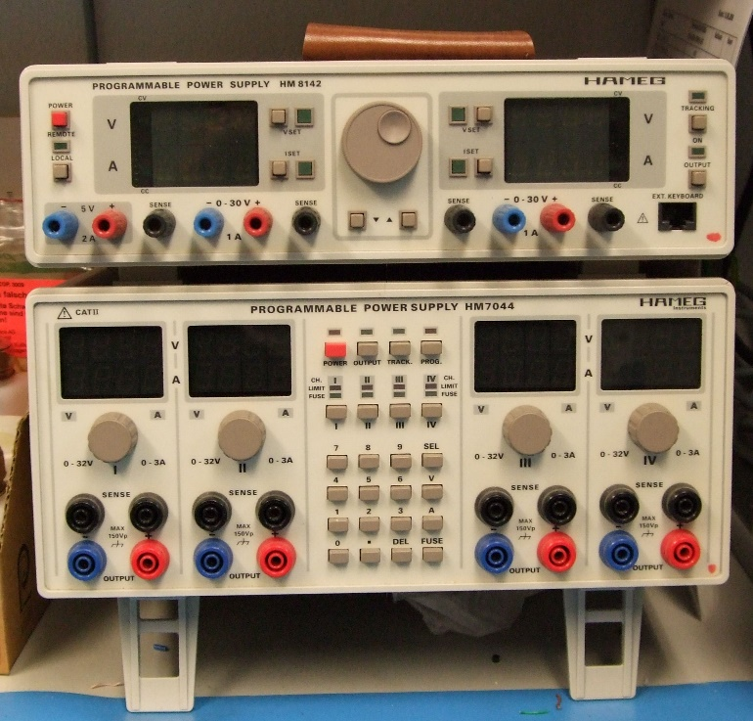

Fig 2- Programmable power supply

* 1. ***Uninterruptible power supply (UPS)***

An uninterruptible power supply (UPS) is a device that allows a computer to keep running for at least a short time when the primary power source is lost. UPS devices also provide protection from power surges.

A UPS contains a battery that "kicks in" when the device senses a loss of power from the primary source. If an end user is working on the computer when the UPS notifies of the power loss, they have time to save any data they are working on and exit before the secondary power source (the battery) runs out. When all power runs out, any data in your computer's random-access memory (RAM) is erased. When power surges occur, a UPS intercepts the surge so that it does not damage the computer. [7]

Other UPS schemes may use an internal combustion engine or turbine to supply power during a utility power outage and the amount of battery time is then dependent upon how long it takes the generator to be on line and the criticality of the equipment served. Such a scheme is found in hospitals, data centers, call centers, cell sites and telephone central offices. [8]

* 1. ***High-voltage power supply***

A high-voltage power supply is one that outputs hundreds or thousands of volts. A special output connector is used that prevents arcing, insulation breakdown and accidental human contact. Federal Standard connectors are typically used for applications above 20 kV, though other types of connectors (e.g., SHV connector) may be used at lower voltages. Some high-voltage power supplies provide an analog input or digital communication interface that can be used to control the output voltage. High-voltage power supplies are commonly used to accelerate and manipulate electron and ion beams in equipment such as x-ray generators, electron microscopes, and focused ion beam columns, and in a variety of other applications, including electrophoresis and electrostatics.[9]

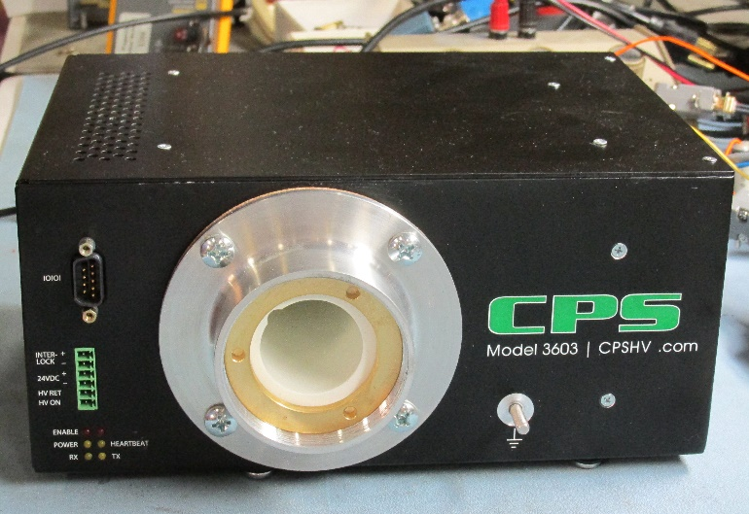

Fig 3- A 30 kV high-voltage power supply with Federal Standard connector, used in electron microscopes

There is no universally accepted definition of how high a voltage must be in order to be considered a high voltage, though a power supply with an output of 1,000 volts or more is virtually always considered to be High Voltage Power.[9]

* 1. ***Bipolar Power supply***

A bipolar power supply operates in all four quadrants of the voltage/current Cartesian plane, meaning that it will generate positive and negative voltages and currents as required to maintain regulation.[4] When its output is controlled by a low-level analog signal, it is effectively a low-bandwidth operational amplifier with high output power and seamless zero-crossings. This type of power supply is commonly used to power magnetic devices in scientific applications. [10]

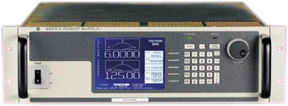

Fig 5- Bipolar Power Supply

* 1. ***DC Power Supply***

An AC-to-DC power supply operates on an AC input voltage and generates a DC output voltage. Depending on application requirements the output voltage may contain large or negligible amounts AC frequency components known as ripple voltage, related to AC input voltage frequency and the power supply's operation. A DC power supply operating on DC input voltage is called a DC-to-DC converter. This section focuses mostly on the AC-to-DC variant.

DC power supplies are used for a wide range of applications from training the next generation of electrical engineers to developing breakthrough ultra-low power, wearable products. Whether you need a DC power supply that provides basic power sourcing or one that pushes the limits of performance by delivering thousands of volts, choosing the appropriate power supply is critical to obtaining successful test results in teaching, research, design, and manufacturing.[11]

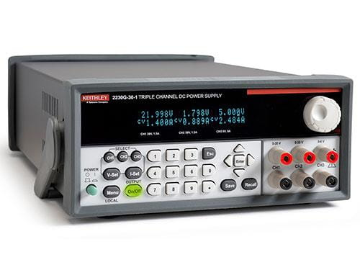

Fig 6- DC Power Supply

* + 1. ***Linear power supply***

In a linear power supply the AC input voltage passes through a power transformer and is then rectified and filtered to obtain a DC voltage. The filtering reduces the amplitude of AC mains frequency present in the rectifier output and can be as simple as a single capacitor or more complex such as a pi filter. The electric load's tolerance of ripple dictates the minimum amount of filtering that must be provided by the power supply. In some applications, ripple can be entirely ignored. For example, in some battery charging applications, the power supply consists of just a transformer and a diode, with a simple resistor placed at the power supply output to limit the charging current.

Linear power supply or also known as linear regulator uses a transistor that operates in linear mode; not as a switch. Linear power supply has a bulky steel or iron laminated transformer. This transformer has two purposes which are to provide a safety barrier for the low voltage output from the AC input and to reduce the input from typically 115 V or 230VAC to a much lower voltage [12].

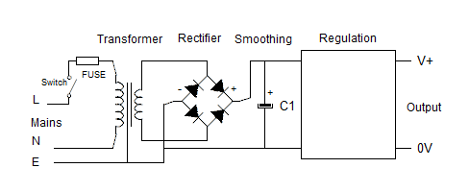

Fig 7- Linear power supply

* + 1. ***SMPS (Switched-Mode-Power-Supply)***

In a switched-mode power supply (SMPS), the AC mains input is directly rectified and then filtered to obtain a DC voltage. The resulting DC voltage is then switched on and off at a high frequency by electronic switching circuitry, thus producing an AC current that will pass through a high-frequency transformer or inductor. Switching occurs at a very high frequency (typically 10 kHz — 1 MHz), thereby enabling the use of transformers and filter capacitors that are much smaller, lighter, and less expensive than those found in linear power supplies operating at mains frequency. After the inductor or transformer secondary, the high frequency AC is rectified and filtered to produce the DC output voltage. If the SMPS uses an adequately insulated high-frequency transformer, the output will be electrically isolated from the mains; this feature is often essential for safety.[13]

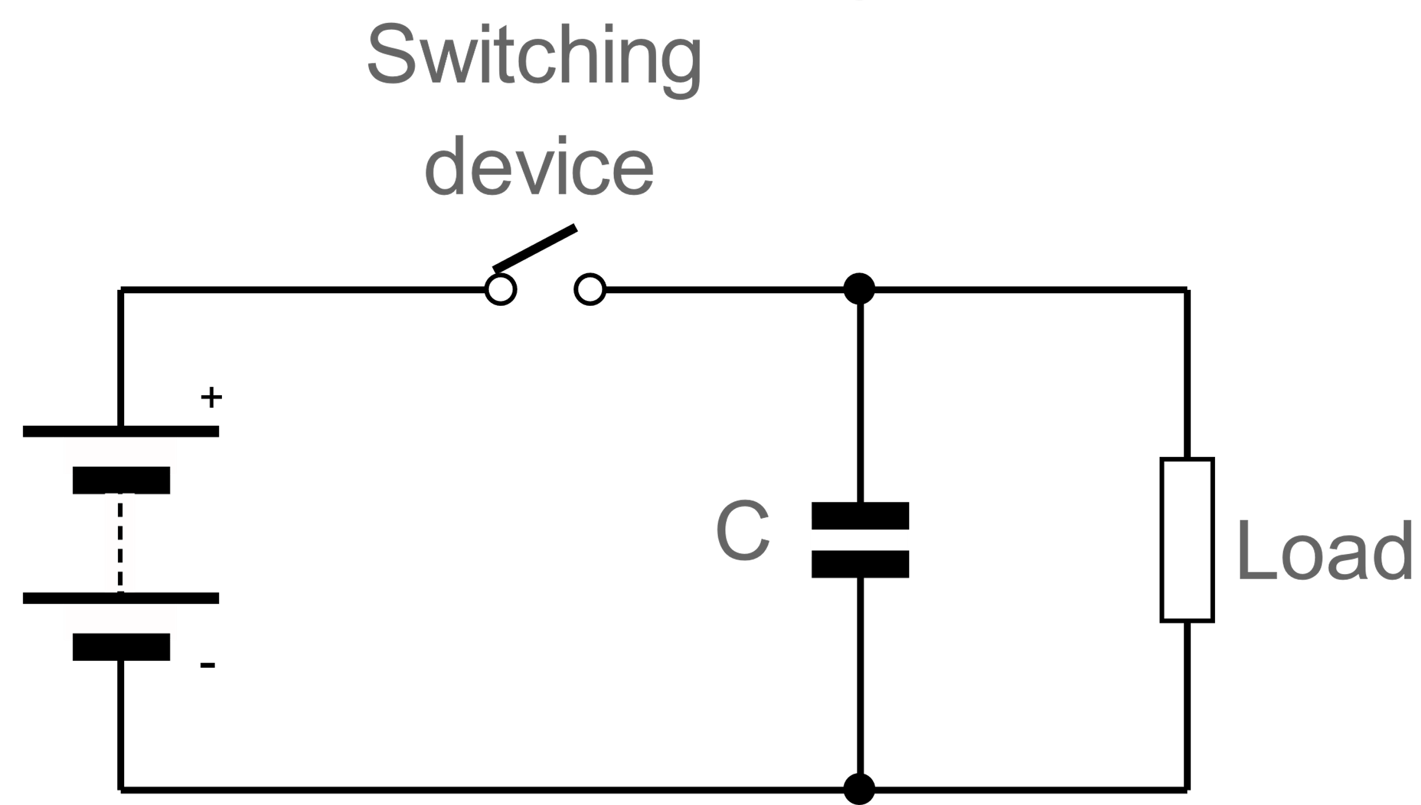

Fig 8- basic smps circuit

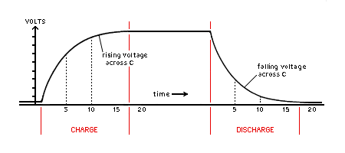

Fig 9- capacitor charge-discharge time

Advantage of SMPS inhibits a greater efficiency because the

switching transistor dissipates little power as it functions as a switch. When the transistor acts like a switch, it is either has a zero voltage drop across it or a zero current through it. Other advantage is lower heat generation due to higher efficiency compared to linear power supply.[13]

* + - 1. ***Types of SMPS***

Types of SMPS or SMPS Topologies are the ways in which the various circuit configurations of switch mode power supply are classified. In broad sense, a switch mode power supply is categorized as, non-isolated SMPS and isolated SMPS.

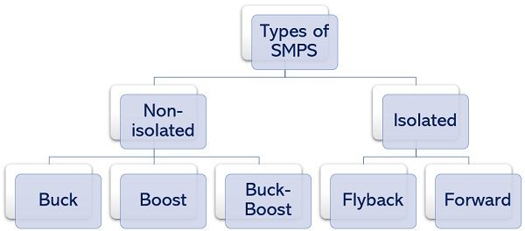

Fig 10- Types of SMPS

***Non-Isolated***

The non-isolated SMPS are the ones whose input and output circuitry are not isolated from each other. Though there many non-isolated SMPS exists, the three main types of non-isolated SMPS are Buck, Boost, and Buck-Boost SMPS. In these switch mode power supplies, no such device is used that can separate the switching circuit from that of output. Here inductors are used as energy storing elements.

***Isolated***

While the isolated SMPS are the ones where there is isolation maintained between the input and output circuitry. Despite the existence of several isolated SMPS, the two types majorly known are Flyback Converter and Forward Converter. These switched mode power supplies make use of a transformer to separate the switching from the output. The secondary winding of the transformer acts as the energy storing element.[14]

***Buck Converter***

Buck switching regulator is the one that produces the dc output signal with a value less than the supplied input signal. Hence, is given another name, step down converter.

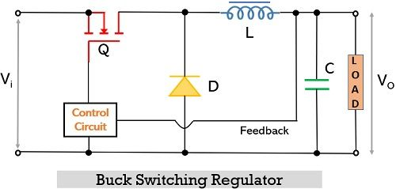

Figure 11- The circuit representation of the buck switching regulator

Here, it is formed using 2 switches i.e., a transistor, Q, and a diode, D, along with an energy storing element i.e., inductor, L. The capacitor, C is used for smoothing purposes. The two modes of operation of this circuit are dependent on whether the transistor is on or off.

When a high input pulse (Forward Bias) is provided then the transistor gets on and D gets reverse biased. Due to reverse biased condition, no current will flow through the diode and the current from the transistor will reach the load through the inductor. According to Faraday’s law, the inductor will oppose the change in current. Thus, the load current shows a gradual rise with expansion in a magnetic field, meanwhile the inductor stores energy. Also, this current will charge the capacitor C, up to supply voltage, connected across the load.

When a low input pulse (Reverse Bias) is provided then the transistor will get off and no current will flow through it. In the absence of external supply, the magnetic field around the inductor will not sustain thereby inducing a voltage of reverse polarity across the inductor. So, the voltage existing across the inductor will now make the diode forward biased and this time the current flows through the load via a diode. Simultaneously the charge within the capacitor is also supplied to the load. This will take place till the time transistor starts conducting again.[14]

In the off state of the transistor, the inductor and capacitor will act as LC filter that will smooth out the ripples due to the switching action of the transistor.



***Boost Converter***

A boost type of SMPS produces such a dc output signal whose value is more than the supplied input signal. Thus, sometimes called step up converter. The figure below shows the circuit representation of the boost converter:

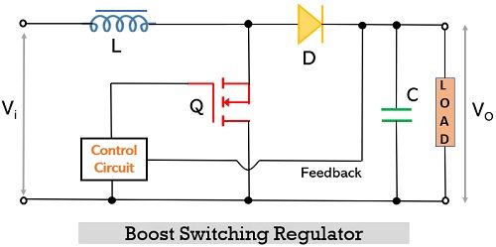

Figure 11- The circuit representation of the buck switching regulator

In the boost configuration, when the high pulse (forward bias) is present at the input then the transistor gets on. Here the current is allowed to flow starting from the inductor through the transistor and back to the supply input. At this time no current will reach the load due to the reverse-biased configuration of the diode relative to the transistor but the inductor will store the energy.

While when the negative pulse is present at the input, then the transistor will come in a non-conducting state. Due to the switched-off transistor condition, the diode will now be forward biased and will start conducting. In this condition, the supply input will be delivered to the load via a forward-biased diode. Also, the energy stored in the inductor will also be delivered to the load simultaneously.

So, in this case, the total energy delivered to the load will be the sum of input supply energy Vin and energy stored in inductor VL. By this same energy, the C across the load will get charged. When again, the transistor will get on, then the capacitor charged previously will now act as a source and deliver the power to the load.



***Flyback Converter***

In this the switching device is in complete isolation with the output circuit, the circuit representation of the flyback converter given below, clearly shows the same:

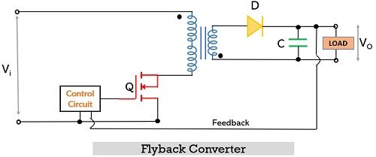

Here flyback transformer is incorporated, in which the only one of the windings conducts at a time. It acts as an energy storage and energy transfer device. To show the polarity of the two transformer windings, dots at both the windings are used.

During the high input pulse, the transistor will get on and the current will flow through the primary winding of the transformer and reaching the supply input. Due to this flow of current, the voltage will get induced in the secondary winding but it is of opposite polarity as the dots in the two windings are in different directions. This reverse polarity at the secondary winding, reverse biases the diode, D. In this condition, the charge stored within the capacitor acts as a source that delivers power to the load. [14]

However, during the low input pulse, the transistor will be off and no current will flow through the primary winding of the transformer. At this time, the secondary winding releases energy and reverses its polarity. This forward bias the diode and current will flow through it. Hence, now the power will be delivered to the load and simultaneously the capacitor will be charged.

***Forward Converter***

The forward converter is also based on an isolated type of SMPS that incorporates a transformer. The figure below represents the circuit of forward converter where the two dots correspond to the same polarity at both the winding of the transformer:

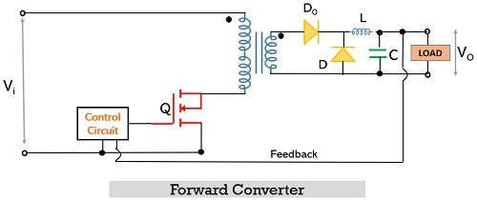

When a high input pulse is provided then the transistor gets on and the current starts flowing through the primary winding of the transformer. This flowing current in the primary winding induces a current in the secondary winding. However, unlike flyback converter, here the polarity on both the winding is the same. These forward biases the diode D0 and the current will reach the load by passing through the inductor and charging the capacitor. The flowing current will store the energy within the inductor.

But as soon as a low input pulse is given the transistor gets off and no current flows through the primary winding of the transformer. Hence, no voltage will further induce in the secondary winding. In this case, the energy stored in the inductor will forward biases the diode D and it supplies the energy to the load. After the energy within L gets completely exhausted the capacitor will further act as a source of energy.

These are comparatively complex than flyback converter and used in high power requirement applications.[14]

# Application

The switch mode power supply (SMPS) is used in personal computers.

* It is used in machine tool industries.
* The SMPS is used in security system.
* It is used in railway system.
* It is also used in mobile.
* It is used in battery charger.
* The SMPS is used in vehicles.
* It is also used in lighting.
* It is used in servers, power stations, and personal computers.[15]

***Advantages & Disadvantages of SMPS***

***Advantages***

• Smaller in size and light-weighted.

• Better power efficiency of around 60 to 70 percent.

• Strong anti-interference.

• Wide range of output.

• Produces less heat.

***Disadvantages***

• The SMPS design & working is more complex.

• Has higher output ripple and its regulation is not satisfactory.

• Mostly limited to the step-down regulator.

• Has high-frequency electrical noise.

• Leads to harmonic distortion.[16]

# Description on the operation of the circuit

***Rectifying circuit***

A rectifier is an electrical device that converts alternating current (AC), which periodically reverses direction, to direct current (DC). Others require power sources to drive protective current in the right direction. The most common impressed current voltage sources are rectifiers, which can break down.

We used Single phase bridge rectifier in our circuits. This rectifier converts a 220V AC voltage to 30V DC voltage.

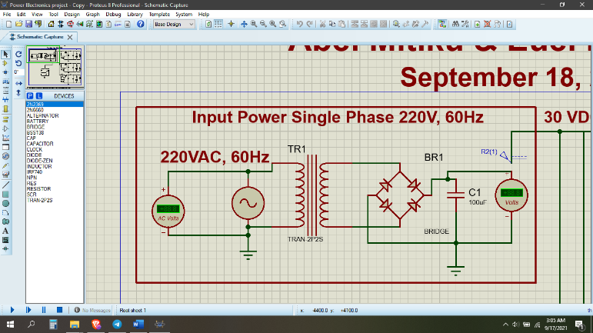

We used Buck converter in our output voltages circuits.

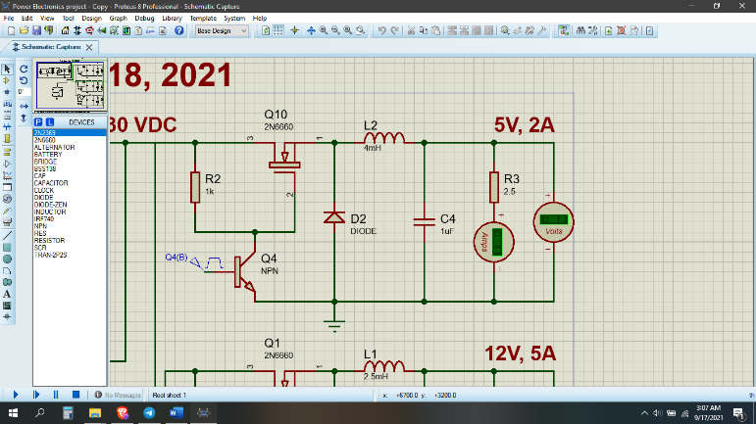

And we compute the capacitors and inductor values as per the requirement voltage, For example the sketch calculation for 5V and 2A current output is in the figure below.

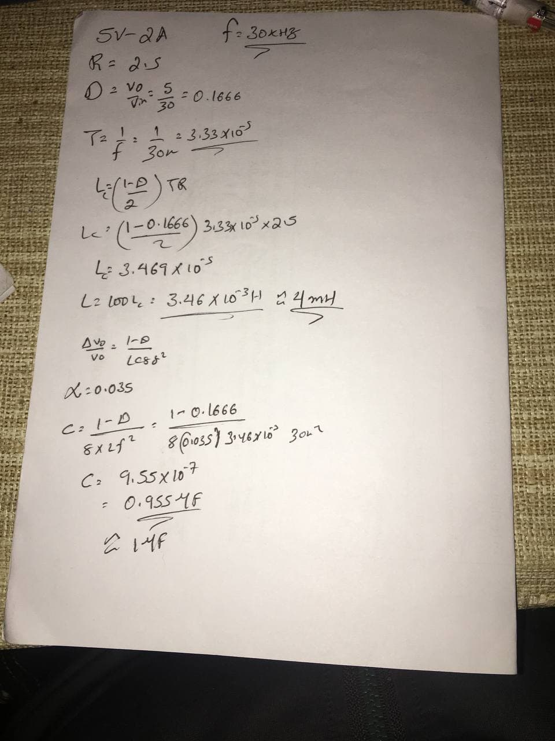

***Method of Protection***

To protect the SMPS from overvoltage, instead of shutting down the system instantly when during fault, alternatively, a “crowbar” circuit may be used, where a thyristor is triggered if the voltage at the gate of the thyristor rises above the threshold voltage, putting a short circuit across the output, hence, clamping the output voltage low, with the current controlled by the current limit circuit.

When the voltage at the input Vin exceeded the breakdown voltage of the Zener diode, the voltage, Vz will flow through Zener diode in reverse direction. If Vz is more than the

threshold voltage of the SCR, the SCR will be triggered. Hence, the output voltage, Vo will be shorted. By using this method, the system can still operate even when the voltage has exceeded the limit.

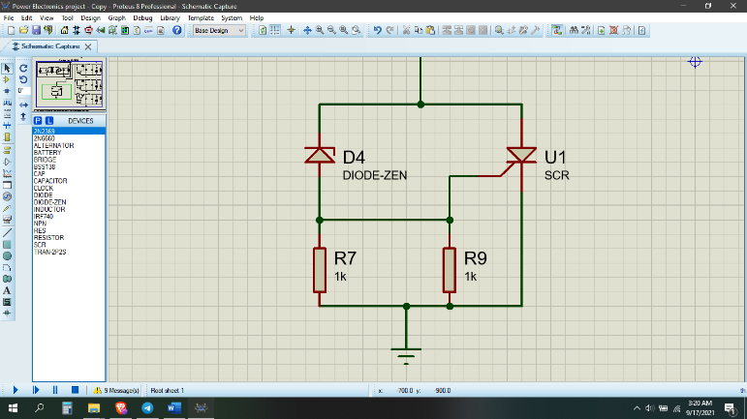

# Simulation & Results

***Results of the Power Supply***

***Results of Rectifier***

Input & Outputs

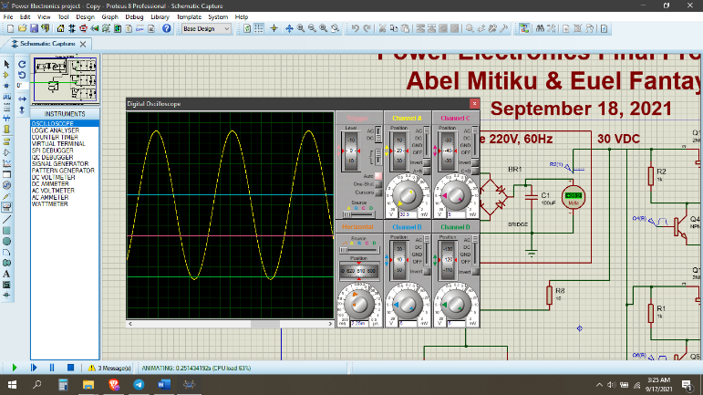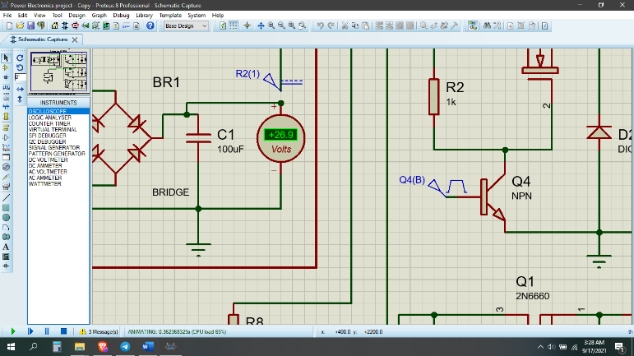

The Output voltages (12V, 5V, 24V)

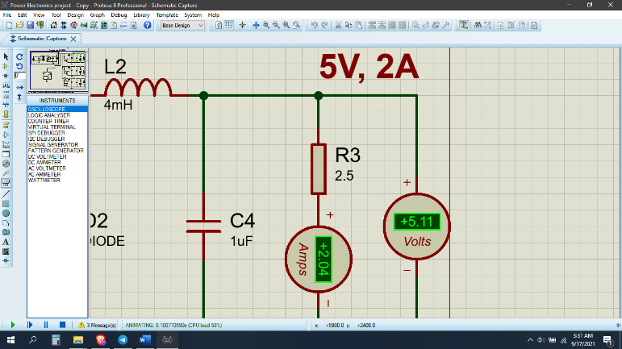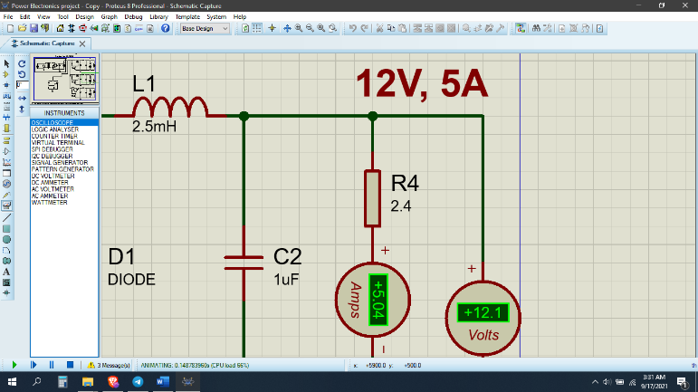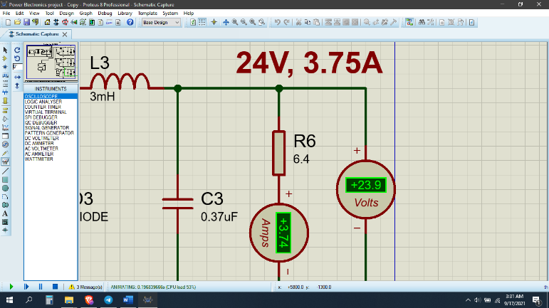

We have got 1.25% difference than the

required voltage. Which is pretty good.

# Conclusion

In the end, the expectation of the SMPS to have three output levels which are 5V, 12V and 24V are met. In this project, overvoltage protection is installed in AC-to-DC Switched Mode Power Supply (SMPS). The SMPS is developed by full-bridge rectifier. The crowbar thyristor circuit is used to

protect the circuits from overvoltage.

# Acknowledgment

We would like to thank our lecturer, Mr. Nebyu Y, for his support and guidance all this time and for giving us the exposure to write this paper on the title SMPS which led us to read many papers on the topic and gained a knowledge on the topic and also on how to write a standard IEEE format paper. Thank You!

# Each member contribution

***Euel Fantaye*** – Description & Operation of circuit, Conclusion, Discussions, Simulation & Result.

***Abel Mitiku*** – Introduction, Literature Review, Application, Simulation & Result.

# Reference

[1] Understanding switched-mode power supplies (SMPS) [online] Available: <https://www.avnet.com/wps/portal/abacus/solutions/technologies/power/the-design-engineers-guide/switched-mode-power-supplies/>

[2] What is switch mode power supply? [online] Available:

<https://www.sunpower-uk.com/glossary/what-is-switch-mode-power-supply/>

[3] Switch Mode Power Supply [online] Available:

<https://www.electronics-tutorials.ws/power/switch-mode-power-supply.html/>

[4] Multiple Output SMPS with Improved Input Power Quality by S. Singh, G. Bhubaneswar, and B. Singh

[5] Power supply, Wikipedia [online] Available:

<https://en.wikipedia.org/wiki/Power_supply>

[6] Programmable Power Supplies [online] Available:

<https://www.circuitspecialists.com/programmable-power-supplies>

[7] Uninterruptible power supply (UPS) By

Robert McFarlane, Shen Milsom & Wilke LLC, Available:

<https://searchdatacenter.techtarget.com/definition/uninterruptible-power-supply>

[8] Uninterruptible power supply Main article Wikipedia, Available:

<https://en.wikipedia.org/wiki/Power_supply>

[9] High Voltage power supplies article apopain, Available:

<https://www.acopian.com/high-voltage-power-supplies.html>

[10] Bipolar Power supplies, Wikipedia, Available:

<https://en.wikipedia.org/wiki/Power_supply>

[11] Matching the DC Power Supplies to the Application, [online] Available:

<https://www.tek.com/dc-power-supply>

[12] National Instrument. Linear Versus Switch Mode Power

Available:

<https://www.circuitspecialists.com/blog/power-supplies-switch-mode-vs-linear/>

[13] Switched Mode Power Supply, [online] Available:

<https://en.wikipedia.org/wiki/Power_supply>

[14] Types of SMPS [online] Available:

<https://electronicscoach.com/types-of-smps.html>

[15] Switched Mode Power Supply: SMPS Design & Applications, [online] Available:

<https://how2electronics.com/switched-mode-power-supply-smps-design-applications/>

[16] Application of switch mode power supply (SMPS), [online] Available:

<https://www.polytechnichub.com/application-switch-mode-power-supply-smps/>

1.